

dIgital logic and design

LAB FAT

­­

Name: **VIBHU KUMAR SINGH**

Reg. No: **19BCE0215**

Teacher: **Sairabanu J.**

**4. A) Design a Full adder and full subtractor using decoders.**

**B) Design bidirectional shift register with the following functionality:**

**0 0 -- Shift left**

**0 1 -- Parallel Load**

**1 0 -- Insert zero to the inputs**

**1 1 -- Shift right**

A)

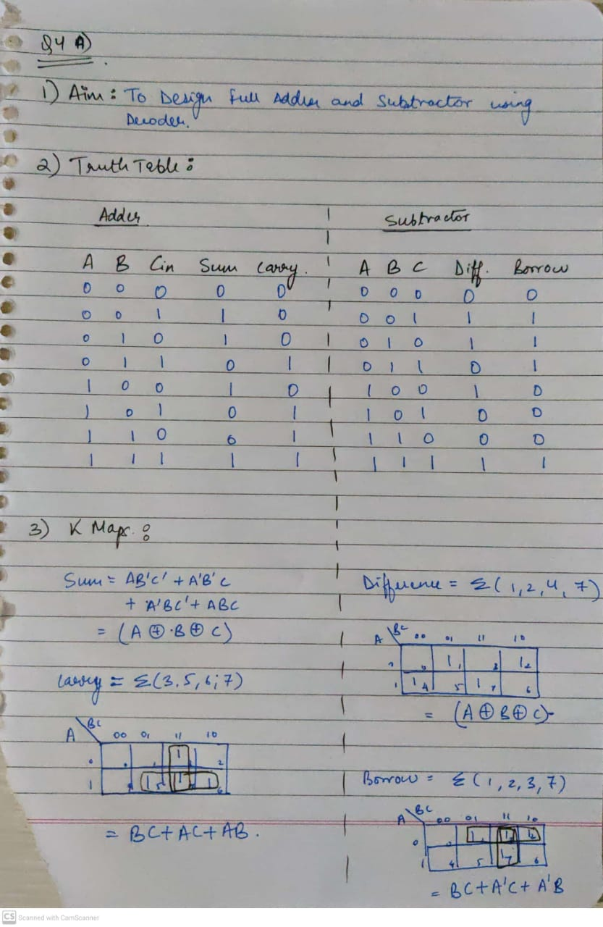

Design:

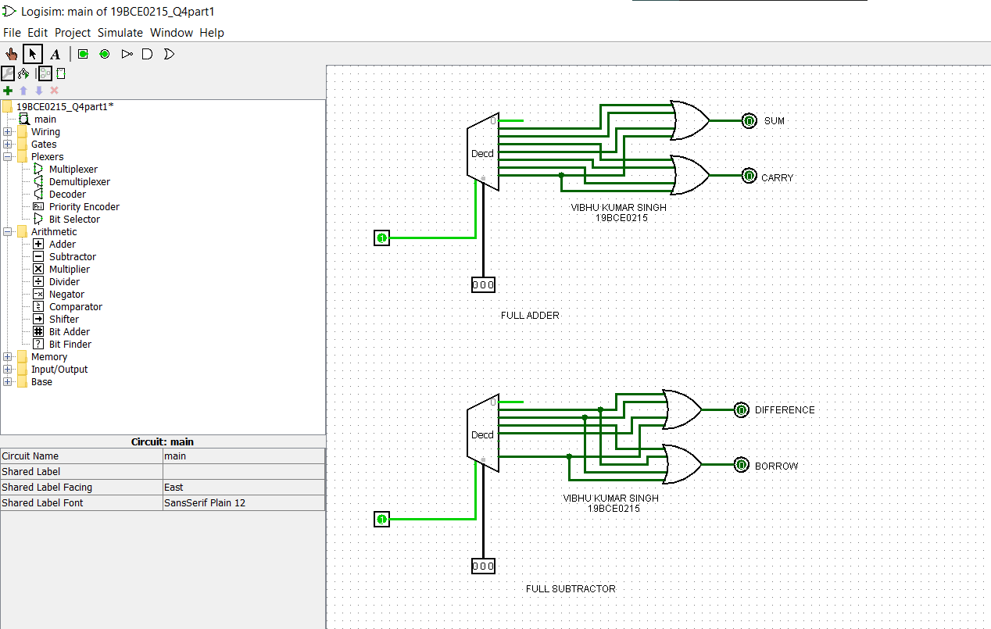

OUTPUT:

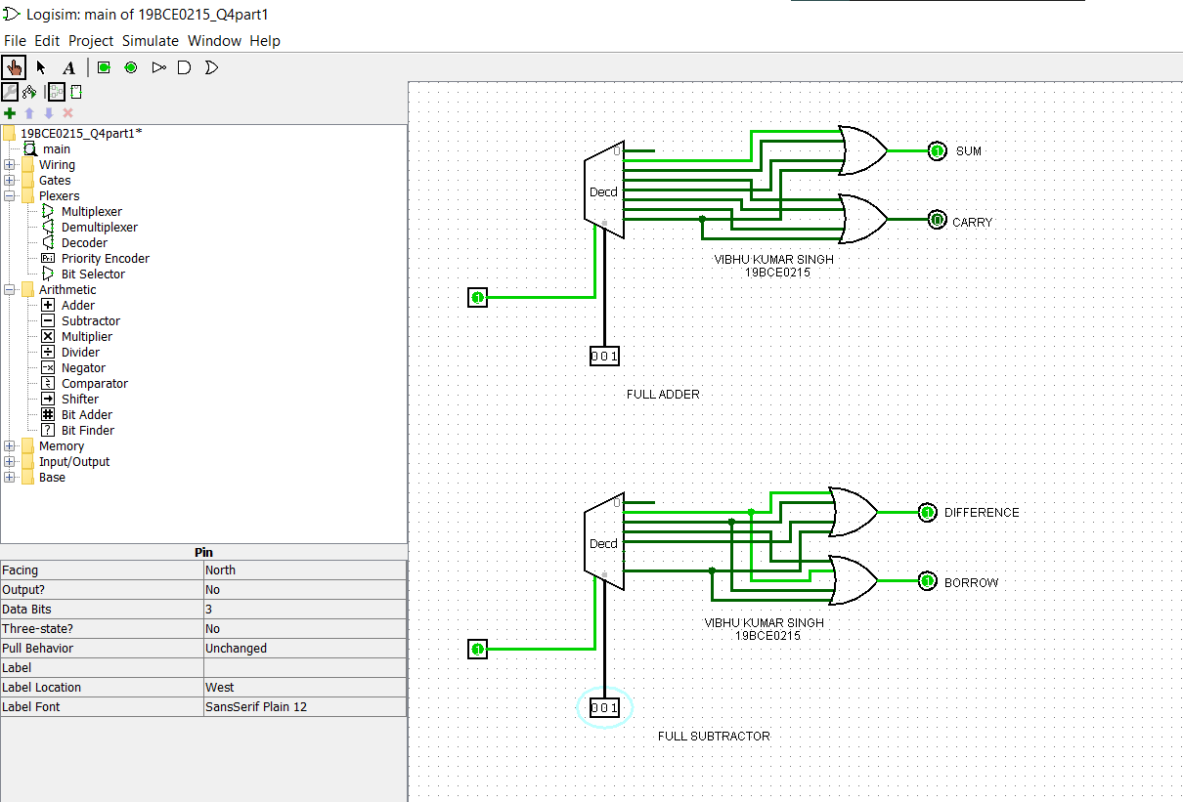

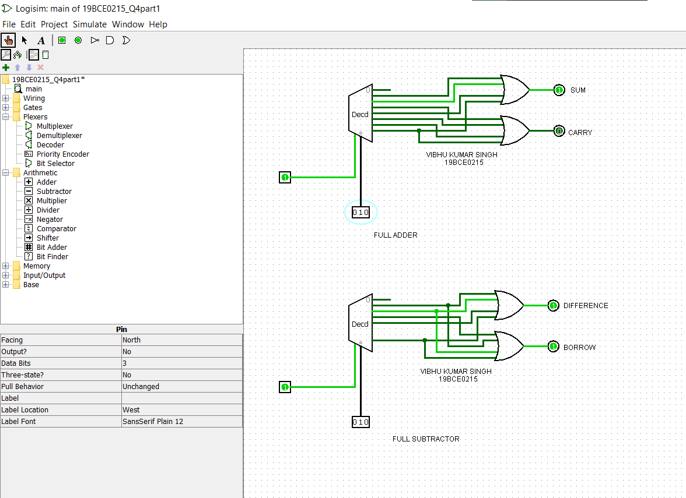

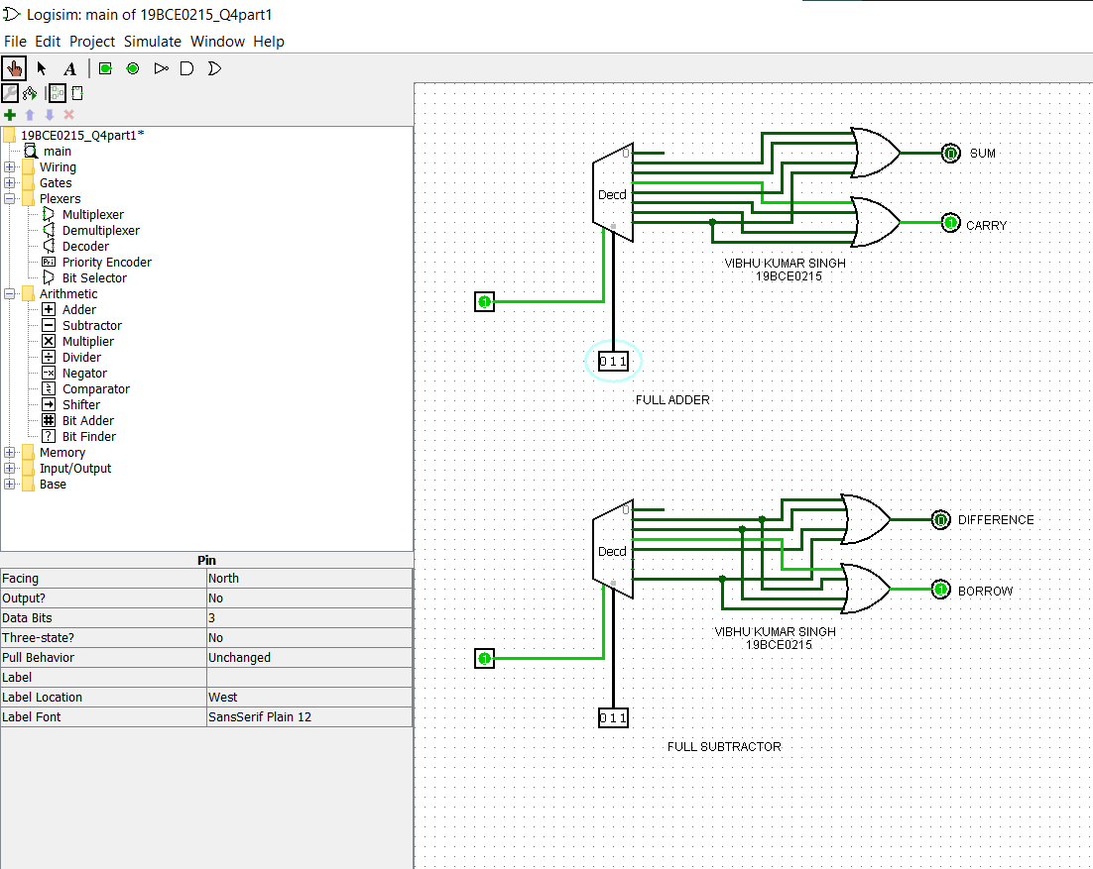

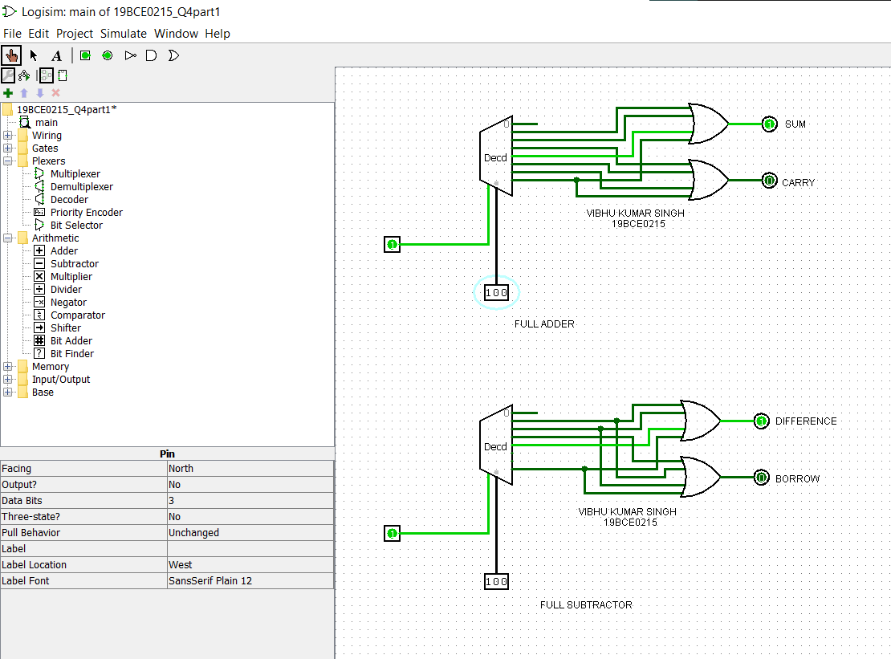

B)

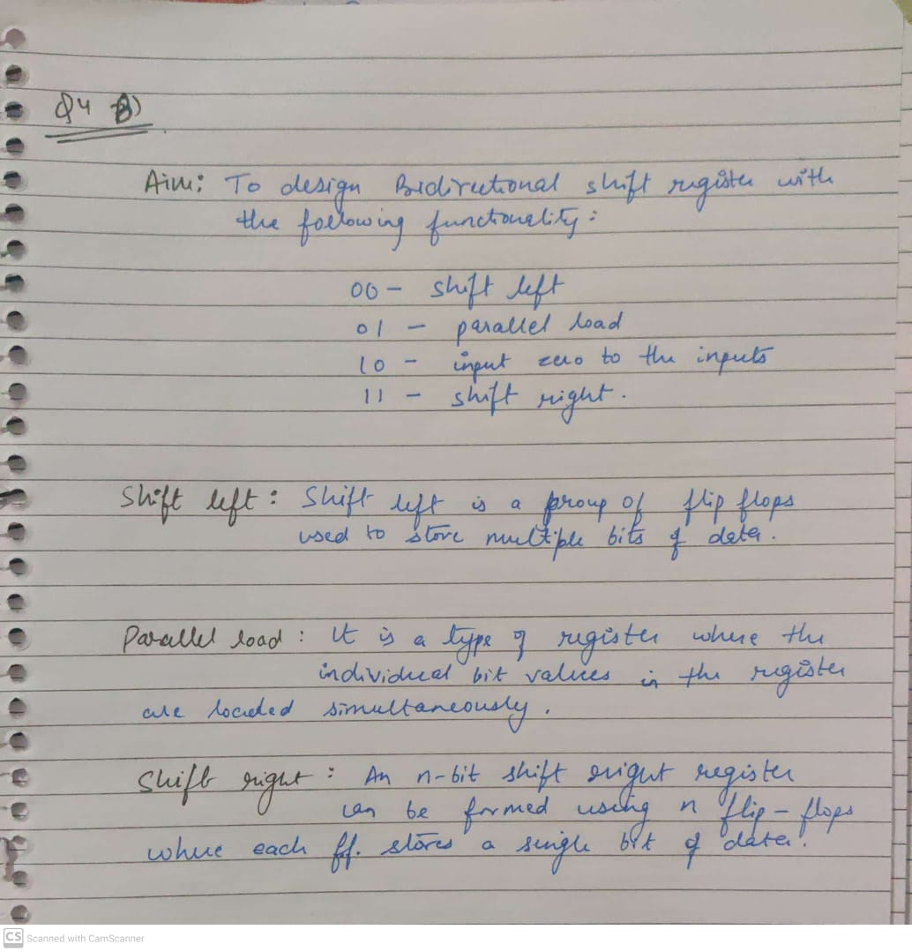

Design:

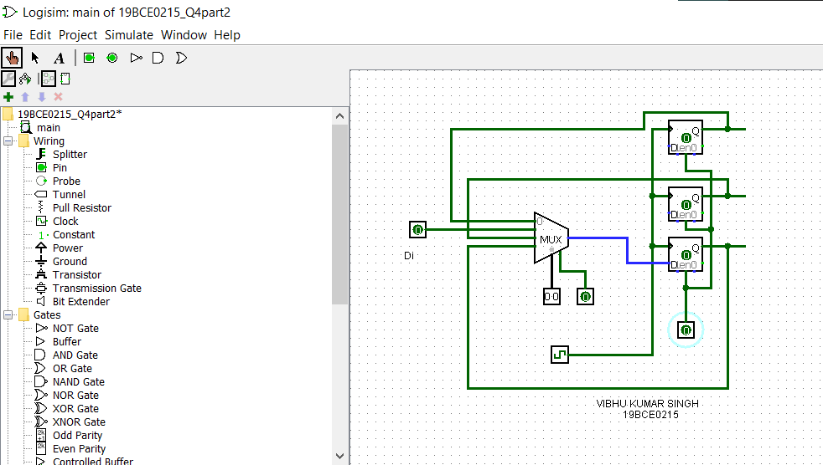

OUTPUT:

